Shorufa’s Story
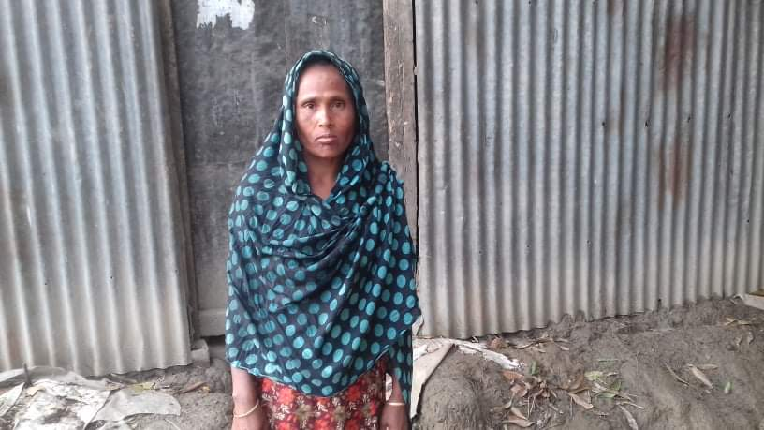
Shorufa Begum lives in Chatirchar Union in Kishoreganj with her husband Labu Mia who is seriously ill at home and their children. Shorufa is responsible for supporting her family and works as a day labourer or domestic help. Despite working very long hours, her income is not always enough to provide all the food her family needs.
To prevent the spread of Covid-19 the government has put her area under lockdown so people’s mobility is strictly limited. Now she is unable to go out to work because the lockdown means she has lost her job. Shorufa’s meager savings lasted a couple of days and she is struggling to provide food for her family.
“I have never faced such a challenge. Usually every year we experience a bad time during the monsoon when floods or flash floods disturb our livelihoods. But those natural calamities do not last this long.” Shorufa said. ”This time we have nothing to do but to starve and we will not survive, unless the government or well off people come to our rescue.”
Learning for Life and POPI has supplied foods packs and hygiene kits to Shorufa’s family to provide them with support during the Covid-19 pandemic.

